SỞ GIÁO DỤC VÀ ĐÀO TẠO  HẢI DƯƠNG  ĐỀ CHÍNH THỨC | KỲ THI TUYỂN SINH LỚP 10 THPT  CHUYÊN NGUYỄN TRÃI  NĂM HỌC 2018-2019  Môn thi: TIẾNG ANH (chuyên)  Thời gian làm bài: 120 phút  (Đề thi có 08 trang)
Thí sinh làm bài vào tờ giấy thi.
Phần trắc nghiệm: Chỉ cần viết chữ cái A hoặc B, C, D.
Phần tự luận: Viết đầy đủ theo yêu cầu của bài.
(Thí sinh không được sử dụng bất kỳ tài liệu gì.)
_______________________________________________________________
A. LISTENING
Hướng dẫn làm bài thi nghe
Bài thi nghe gồm có 04 phần, mỗi phần thí sinh được nghe 02 lần. Mở đầu và kết thúc phần thi nghe có tín hiệu nhạc.
Mọi hướng dẫn cho thí sinh (bằng tiếng Anh) có trong bài.
I. Listen to five small conversations and choose the best option to answer each question. (5 points)
1. Where are the dictionaries?
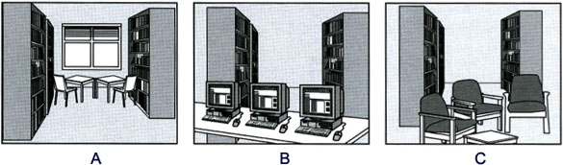
2. What evening dress code does the woman decide to wear?

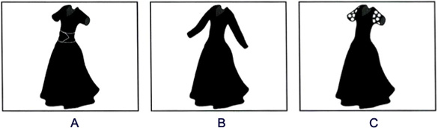
3. What is the man’s job now?
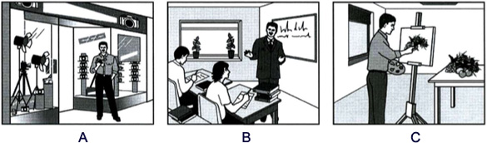

4. Which calendar will the boy buy?
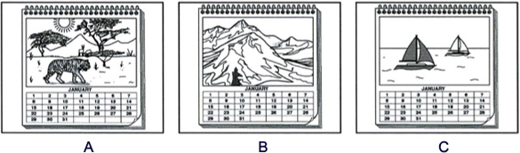
5. What time will the writer arrive at the bookshop?
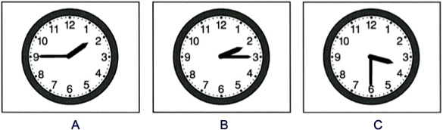
II. Mrs. Green is taking students on a tour on their first day at school. Listen and fill each of the gaps with NO MORE THAN TWO WORDS AND/ OR TWO NUMBERS. (5points)
Place | Opening Hours | Facilities
Library | (6)_______________ | Books, (7) ___________ and computers
Laboratory | (8) ________________ | Computers and (9) _________________
(10) ___________ | 11.30 am - 12.30pm | Microwave

III. You will hear a telephone conversation about hotel reservations. As you listen, fill the missing information in the numbered space. (NO MORE THAN TWO WORDS AND/ OR TWO NUMBERS) (5points).
HOTEL RESERVATIONS
11. The man finally makes a reservation for two on _________________.
12. The man prefers a ___________________ room.
13. He doesn’t want to reserve the suite because it is _________________.
14. Including tax, the man's room is ___________________________$.
15. The man's name is ___________________________.

IV. Listen to part of a speech. Choose the best answer for each question below. (5 points)
16. Graduate schools in the United States have increased by _____in applications from international students this year.
A. seven percent B. eight percent C. nine percent D. ten percent
17. The increase this year is the same as ______.
A. two years ago B. three years ago C. four years ago D. five years ago

18. The countries that showed the biggest increase in master and doctoral program enrollment this fall are ______.
A. China and Taiwan B. China and Mexico C. Mexico and Brazil D. China, Mexico and Brazil
19. The top area of study for international students is ______.
A. Engineering B. Business C. Physics D. Earth sciences
20. The survey was conducted by ______.
A. South Korea B. The Council of Graduate Schools C. India D. Brazil

B. GRAMMAR – VOCABULARY – LANGUAGE FUNCTIONS
I. Choose the word, phrase or expression that best completes each sentence below. (10 points)
21. You ______ the plants. If you had, they would not have died.
A. needn’t have watered B. can’t have watered
C. shouldn’t have watered D. mustn’t have watered
22. Almost all students are working as hard as they can _______ the highest result in the coming exam.
A. to get B. get C. have got D. be getting
23. He was so excited about the exam result that he burst ______ song.
A. out B. over C. up D. into
24. Thank you so much for your timely support. ______ it, I couldn’t have completed my project in time last month.
A. Due to B. Without C. As a result of D. Regarding
25. Almost all audiences at the beauty contest agreed that her beauty was beyond ______.
A. comparable B. comparative C. compare D. comparison
26. Mr. Thomson: “I think that the youth today are very ambitious but impatient”
Mr. John: “______”
A. You can say that again B. Well, that’s out of the question
C. Thanks for the news D. Yes, It’s my pleasure
27. Mary: “Give my best regards to your parents.” Tom: “ ______”
A. Thanks, I will B. I’m glad to hear that
C. Yes, I guess it’s very good. D. There’s no doubt about it.
28. Jack: “Why don’t we eat out in a restaurant tonight?” Bob: “ ______”
A. Yes, of course you can B. Good idea C. That’ll be very miserable D. Yes, let’s not.
29. Thanh: “Can I share the book with you? I left mine at home.” Binh: “______”
A. Good job! B. Feel free! C. Never mind! D. It’s nice of you to say so!
30. The director has _____ a lot of criticism over his handling of the company affairs.
A. stood in with B. cut down on C. come in for D. gone in for

II. Supply the correct form of the word in bracket to complete the following sentences. (5 points)
31. Jack was extremely ______ at the meeting yesterday. Everyone was taken aback by what he said.
( SPEAK)
32. He laughed ______ and hurt his girlfriend’s feelings. (THINK)
33. The way he behaved at the conference last time was unbearable. His attitudes were totally ______. (DEFENCE)
34. Two _____ from the group called “Friends of The Earth” are talking to the students in the major lecture hall this Saturday. (REPRESENT)
35. All the members of the committee are ______ in favor of the change. (HEART)
C. READING
I. What does each text say? Choose the correct explanation A, B or C. (5points):
36.
STUDENTS!  YOUR $6 DEPOSIT FOR LOCKER KEYS WON’T BE REFUNDED IF KEYS ARE LOST. | A. Lost locker keys can be replaced for a charge of $6.  B. You cannot collect your locker keys until you have paid a $6 deposit.  C. We cannot return your $6 deposit if you lose your locker keys.
37.
SCHOOL FITNESS CENTRE  FROM THE END OF AUGUST, THE FITNESS CENTRE WILL BE CLOSED DURING THE WEEKENDS AND EVENINGS. | The school fitness center will  A. change its opening hours at the end of August.  B. have shorter opening hours until the end of August.  C. open again to students at the end of August.
38.
BOOKS IN THE CAFÉ  PLEASE REMEMBER THAT ONLY BOOKS THAT HAVE BEEN PAID FOR MAY BE TAKEN INTO THE BOOK SHOP CAFÉ | - A. You should pay for your books in the café.  - B. You must read your books in the café.  - C. You must not take any unpaid books to the café.
39.
- Having a great holiday!  - Went windsurfing today after playing beach volleyball.  - Stopped for a barbecue on the way to funfair yesterday.  - See you soon!  - Louis | - A. Louis went windsurfing after he went to the funfair today.  - B. Louis played beach volleyball before he went windsurfing.  - C. Louis went to the funfair before he had lunch.
40.
A. Some photocopies are now cheaper than they were.
B. There are changes to the prices of all photocopies.
C. There is no longer any color photocopying here.

II. Read the following passage and choose the option that best fits each of the space below.
(10 points)
One of the most ______(41) environmental problems in the world today is the shortage of clean water. Having clean drinking water is basic human right. Yet, acid rain, industrial pollutants and garbage have made many sources of water ______(42). Lakes, reservoirs and even entire seas have become vast pools of poison. Lake Baikal in Russia is one of the largest lakes in the world. It contains a rich ______(43) of animals and plants, including 1,300 rare species that do not exist anywhere else in the world. However, they are being destroyed by the massive volumes of industrial waste which are poured ______(44) the lake every day. Even where law existed, the government did not have the power to ______(45) them. Most industries simply ______(46) the regulations. Although the Mediterranean Sea occupies 1% of the world’s water surface, it is the dumping ______(47) for 50% of all marine pollution. Almost 16 countries regularly throw industrial wastes a few miles offshore.
Water is free ______(48) everyone. A few years ago, the supply of clean water in the world was thought ______(49). Today, many water supplies have been ruined by pollution and sewage. Clean water is now scarce, and we are at last beginning to respect this ______(50) source. Therefore, critical measures must be taken right away to save water for our future generations.
41. A. fatal B. urgent C. significant D. ingenious
42. A. drunken B. drink C. undrinkable D. drinkable
43. A. amount B. variety C. sum D. species
44. A. into B. out of C. upon D. beyond
45. A. enlarge B. enrich C. entitle D. enforce
46. A. overlook B. abandon C. desert D. ignore
47. A. ground B. space C. room D. pool
48. A. about B. with C. to D. of
49. A. to limit B. to have limitations C. to be limitless D. to have limited
50. A. precious B. valueless C. worthless D. worthy

III. Read the following passage and choose the best answer to each question (10 points)
Staggering tasks confronted the people of the United States, North and South, when the Civil War ended. About a million and a half soldiers from both sides had to be demobilized, readjusted to civilian life, and reabsorbed by the devastated economy. Civil government also had to be put back on a peace time basis and interference from the military had to be stopped.
The desperate plight of the South has eclipsed the fact that reconstruction had to be undertaken also in the North, though less spectacularly. Industries had to adjust to peacetime conditions: factories had to be retooled for civilian needs.
Financial problems loomed large in both the North and the South. The national debt had shot up from a modest $65 million in 1861, the year the war started, to nearly $3 billion in 1865, the year the war ended. This was a colossal sum for those days but one that a prudent government could pay. At the same time, war taxes had to be reduced to less burdensome levels.
Physical devastation caused by invading armies, chiefly in the South and border states, had to be repaired. This herculean task was ultimately completed, but with discouraging slowness.
Other important questions needed answering. What would the future of the four million black people who were freed from slavery be like? On what basis were the Southern states to be brought back into the Union?
What of the Southern leaders, all of whom were liable to charges of treason? One of these leaders, Jefferson Davis, president of the Southern Confederacy, was the subject of an insulting popular Northern song, "Hang Jeff Davis from a Sour Apple Tree", and even children sang it. Davis was temporarily chained in his prison cell during the early days of his two-year imprisonment. But he and the other Southern leaders were finally released, partly because it was unlikely that a jury from Virginia, a Southern Confederate state, would convict them. All the leaders were finally pardoned by President Johnson in 1868 in an effort to help reconstruction efforts precede with as little bitterness as possible.

51. What does the passage mainly discuss?
A. Methods of repairing the damage caused by the war B. Problems facing the United States after the war
C. The results of government efforts to revive the economy D. Wartime expenditures
52. The word "Staggering" in paragraph 1 is closest in meaning to ______.
A. disgusting B. confusing C. fascinating D. overwhelming
53. The word "devastated" in paragraph 1 is closest in meaning to ______.
A. dilapidated B. ruined C. complicated D. evacuated
54. According to the passage, which of the following statements about the damage in the South is correct?
A. It was worse than in the North. B. The cost was less than expected.
C. It was centered in the border states. D. It was remedied rather quickly.
55. The passage refers to all of the following as necessary steps following the Civil War EXCEPT ______.
A. helping soldiers readjust B. restructuring industry
C. returning government to normal D. increasing taxes
56. The phrase " This herculean task " in paragraph 4 refers to ______.
A. raising the tax level B. sensible financial choices
C. reconstruction of damaged areas D. wise decisions about former slaves
57. Why does the author mention a popular song?
A. To give an example of a Northern attitude towards the South
B. To illustrate the Northern love of music
C. To emphasize the cultural differences between the North and the South
D. To compare the Northern and Southern presidents
58. The word "This” in paragraph 3 refers to ______.
A. $65 million B. $3 billion C. the war D. the completion of war
59. Which of the following can be inferred from the phrase "...it was unlikely that a jury from Virginia, a Southern Confederate state, would convict them"?
A. Virginians felt betrayed by Jefferson Davis. B. A popular song insulted Virginia.
C. All of the Virginia military leaders had been put in chains. D. Virginians were loyal to their leaders.
60. It can be inferred from the passage that President Johnson pardoned the Southern leaders in order to ______.
A. help the nation recover from the war B. repair the physical damage in the South
C. prevent Northern leaders from punishing more Southerners D. raise money for the North

IV. Read the passage and decide whether each of the following statements is True (T) or False (F)
(5 points)
Commuting is the practice of travelling a long distance to a town or city to work in the morning, and then travelling home again in the evening. The word commuting comes from commutation ticket, a US rail ticket for repeated journeys, called a season ticket in Britain. Regular travellers are called commuters.
The US has many commuters. A few, mostly on the East Coast, commute by train or subway, but most depend on the car. Some leave home very early to avoid the traffic jams, and sleep in their cars until their office opens. Many people accept a long trip to work so that they can live in quiet bedroom communities away from the city, but another reason is ‘white flight’. In the 1960s most cities began to desegregate their schools, so that there were no longer separate schools for white and black children. Many white families did not want to send their children to desegregated schools, so they moved to the suburbs, which have their own schools, and where, for various reasons, few black people live.
Millions of people in Britain commute by car or train. Some spend two or three hours a day travelling, so that they and their families can live in suburbia or in the countryside. Cities are surrounded by commuter belts. Part of the commuter belt around London is called the stockbroker belt because it contains houses where rich business people live. Some places are becoming dormitory towns, because people sleep there but take little part in local activities.
Most commuters travel to and from work at the same time, causing the morning and evening rush hours, when buses and trains are crowded and there are traffic jams on the roads. Commuters on trains rarely talk to each other and spend their journey reading, sleeping or using their mobile phones, though this is not popular with other passengers. Increasing numbers of people now work at home some days of the week, linked to their offices by computer, a practice called telecommuting.
Cities in both Britain and the US are trying to reduce the number of cars coming into town each day. Some companies encourage car-pooling (called car sharing in Britain), an arrangement for people who live and work near each other to travel together. Some US cities have a public service that helps such people to contact each other, and traffic lanes are reserved for car-pool vehicles. Cars and petrol/gas are cheap in the US, and many people prefer to drive alone because it gives them more freedom. In Britain many cities have park- and-ride schemes, car parks on the edge of the city from which buses take drivers into the center.

No | Statements | True | False
61 | Commuting means taking regular trips to the suburbs for pleasure
62 | Trains and subways are the most common means of transport that most commuters on the East Coast of the U.S take.
63 | Many Europe-origin Americans decided to move away from the city center because they didn’t want their children to learn together with African Americans’ children.
64 | Dormitory towns in Britain are places where commuters take almost no part in local activities.
65 | Free car parks in the city center are measures to reduce the number of cars coming into town each day in the US and/or Britain.

D. WRITING

I. Finish each of the following sentences in such a way that it means exactly the same as the sentence printed before it. (5 points)
66. Passengers always get something to eat on this airline even though the journey is short.
However _____________________________________________________________.
67. People think that an unknown man stole the most valuable picture at the exhibition last night.
The most ______________________________________________________________.
68. “ You should have asked for my permission before taking my bike,” Ha Anh said to Thanh Son.
Ha Anh criticized _________________________________________________________.
69. Finding a suitable job is not a piece of cake to young jobseekers nowadays.
Young jobseekers have ____________________________________________________.
70. Russian authorities are making great efforts because they want to get everything ready for the World Cup.
With a view_____________________________________________________________.
II. Imagine you are the class monitor. Your class is going to hold a class farewell party. Write a letter to your teacher, invite her to the party and tell her about the preparations for the party. (10 points)
You might use the suggestions below.
+ Reasons to hold the party
+ The place where the party will be held
+ Who your class intends to invite to the party
+ What activities have been designed to do during the party
+ Ask her to make some suggestions to make the party memorable
……….

Dear Ms Lan Anh,
……………………………………………………………………………………………………………………………………………………………………..
……………………………………………………………………………………………………………………………………………………………………..
……………………………………………………………………………………………………………………………………………………………………..
……………………………………………………………………………………………………………………………………………………………………..
……………………………………………………………………………………………………………………………………………………………………..
Love,
Quang Hung

III. In about 160 words, write a paragraph discussing the benefits of the Internet as a learning tool for school children. (20 points)

